The Body and Movement in Analysis

By Cedrus Monte

When an individual has been swept up into the world of symbolic mysteries, nothing comes of it; nothing can come of it, unless it has been associated with the earth, unless it has occurred when that individual was in the body…. Only if you first return to your body, to your earth, can individuation take place; only then does the thing become true.
(C. G. Jung, Visions Seminar, 1313-14. )

During my mid-twenties I entered an impasse. Although I was far from being crippled, I could not stand for more than 15 or 20 minutes without experiencing debilitating pain. To counteract the exhaustion, I slept for hours during the day. The doctor finally suggested an operation to fuse the vertebra of my lower back. This was clearly not an option for me, so I began researching different modalities of treatment. Eventually, someone told me about a little known approach called Rolfing, a method of physical manipulation developed by Ida Rolf (1990). In those days, there were only about 30 Rolfers in existence, all trained by Ida Rolf herself. Today, Rolfing is practiced world-wide.

After the series of treatments, I was structurally and psychologically different, very different. Among many other changes, I stood straighter, naturally, becoming taller by almost an inch; without effort, my head rested differently on my torso; my shoe size changed considerably with my feet widening, allowing greater contact with the ground; and most importantly, I no longer experienced pain, a condition which has remained to this day, decades later.

All the energy used to uphold the structural imbalance and withstand the pain was now released, available to propel me forward into life. I felt the ground beneath me as never before; I could stand more readily on my own two feet. I had the energy and strength to meet the world and was eventually able to develop and promote my own work as an artist. In Jungian terms, one might say that the negative complex around which nearly all my libido had been focused was addressed to the extent that I became less regressively bound, constructively aligned with my own individuation process, no longer at such odds with who I was and with how I could serve in the world.

Soon after I was Rolfed, I entered Reichian therapy, a somatically-oriented psychoanalytic approach developed by Wilhelm Reich. Although Reich was a colleague of both Freud and Jung, his work was largely ignored. During the two-year period of my Reichian therapy, the unconscious was approached using the combination of direct hands-on address of body armoring as well as the psychological insight that is part of Reichian work. I was able to understand the deeper psychological significance of the process that unfolded. Most significantly, I became an active participant in the process. I became increasingly sensitive to what was happening physically in my body, at the same time learning to understand the psychological dimension of my feelings and bodily sensations. What I experienced somatically was the mirror image of what I experienced psychologically. As the armoring in my body gradually released, so did the regressive pull of psychological wounds that kept me armored and self-protective.

In time, my somatic explorations as a patient began to shift into somatic training as I continued to seek out and engage other ways of working, including approaches that do not necessarily require direct, hands-on manipulation. These approaches include exercises that employ the weight and positioning of the body as leverage for releasing body armoring and increasing the flow of energy in the body. They also include ways of embodying, through movement, imaginal material from the unconscious such as dreams, waking images, archetypal energies and psychosomatic symptoms.

During the same year I was Rolfed, I was introduced to C. G. Jung's writing. As is the experience for so many, I was deeply touched, his words giving shape and life to what had until that time lay unformed in my own mind. It would not be until some 15 years later, however, that I would enter Jungian training in Zurich where I began to interweave Jungian psychology with my work as a visual artist and the psycho-physical realm of the body. Well into my training, I also encountered the work of other Jungians involved in body-centered analysis, including that of Joan Chodorow (1991) and Marion Woodman (1996).

I have been asked by some, "Do you work with the body in your sessions, or do you work analytically?" From my experience, there is no dichotomy between the two, between working with the body and working analytically with the unconscious. This is not just a theoretical idea. As the reader might understand from the personal story I have shared, it is a deeply felt, experiential knowing of the spirit-matter continuum Jung so carefully traced in alchemical literature and which became pivotal in his work, including his understanding of synchronicity. From my own perspective as an analyst, the "soulwork" that analytical psychology offers can only be fully entered through the experience of the body-mind, psyche-soma unity, a unity that can be understood as the territory itself of the analytical opus. Any separation of body and mind, soma and psyche, in this context is artificial and unnecessarily divisive.

Before describing elements of a somatic, body-centered session, I would like to introduce two points the reader may find useful to understanding how I view the body within analytical psychology. The first discusses the transference; the second, quality of movement.

The Transference in Body-Centered Analysis

Traditionally, the transference in analytical psychology is formed between the analyst and analysand at conscious and unconscious, knowable and unknowable, archetypal and personal dimensions of interaction. Additionally, an important aspect of the transference describes the analyst as "holding" the inherent whole-making, or S/self-healing of the analysand, mirroring it back to the analysand until he or she is able to claim and integrate the whole-making process more readily and more independently.

The same is true for a body-centered Jungian approach. There are, however, from my perspective, notable differences, described in part by the following.

Assuming that individuals are open to working somatically, it is possible for them to gain insight and understanding of unconscious material directly through the body. Even at the beginning of the work, this can take place without the intervention of interpretation from the analyst. This is only possible, however, as a result of the analyst's direct experience of bodily-triggered insight through his or her own personal work. Only then can the analyst encourage the analysand to grow in trust and confidence regarding what is offered up somatically.

I understand this somatic offering as the wisdom of the body, otherwise expressed as the Self contained within the flesh, as the flesh itself (Monte), the experience of which becomes a vehicle for rebuilding and strengthening one's experience of wholeness. Working somatically, the Healer archetype - initially transferred or projected onto the analyst - can more readily become embodied in the analysand. Through direct understanding at the instinctual, bodily level, insight is more fully the analysand's, thus engendering a greater sense of autonomy from the outset. An individual can retain the memory of inner experience more readily than outside interpretation. To this end, accessing bodily knowing can become an immediate resource for positive support and psychic sustenance. We discover that we can rely on ourselves more readily. We learn that we are able to access knowing through the ever-present resource of our own body.

We know what we know because we have experienced it in the flesh of our own being, not because someone has told us it is true.

The transference phenomenon in body-centered analysis or other forms of psychotherapeutic bodywork can, therefore, move quite readily from the interaction between analyst and analysand as primary or ultimate, to bodily experience as the medium which can reflect wisdom, self-awareness and the experience of Self. In other words, the transference field can shift from the interaction between analyst and analysand to a more intra-psychic exchange - that is, between the analysand’s experience through the body and the ensuing self-reflection. The analysand relies far less on interpretation from the analyst and is, rather, encouraged to give voice to somatic experience and, most importantly, to the meaning of that experience.

Thus, there is a turning from the more hierarchical approach with the analyst as "the one who knows," to an approach that fosters direct, instinctual wisdom - the somatic Sophia.

Movement as a Vehicle to and from the Unconscious

It is often the case that in dance and dance-like movement one expresses a feeling, an image, or a sensation; for example, sadness, sitting alone by a river, deadness or rigidity. Since the images provided by this kind of expression are quite often recognizable, one is given a comfortable frame of reference. While this approach is by no means to be excluded from the repertoire of a body-centered analytical approach, the broader idea of movement, for me personally, lies in deeper layers than the expressive one.

In deeper layers, movement is no longer employed in the body to express an image; rather, movement arises in the body as a result of being impressed and moved by the image.

To enter this realm one needs to trust enough, one needs to risk the perceived terrors of entering the darkness of what is not known. Put differently, one allows somatic impulses to momentarily take over without trying to devise a way to express or to control what emerges. When we can empty ourselves of preconceived ideas about how we should move, we create space to receive an impression or impulse from the unconscious. We can allow ourselves to be guided into the movement's own meaning.

Further, the movement becomes that which is being moved. It is not a representation of it. It is not a pantomime. We become, in our physical being, the image from the unconscious: You dream of a door opening.... How is "a door opening" experienced within you, as you?

When speaking about dream images Jung says, "Image and meaning are identical, and as the first takes shape, so the latter becomes clear."(Jung CW 8, para. 402) The impulse or image in the body, in movement, also carries its own meaning: as the movement unfolds, the meaning becomes clear. For this to happen, however, one needs the willingness to be moved, to surrender one's ego long enough to be pierced by the visitation from the unconscious in impulse and movement.

As I experience it, accessing the wisdom of the body lies in the ability to listen and to let ourselves be moved by something greater than ourselves. We no longer move our ego, but we are moved by that which moves us. Only when we wait, without being attached to outcome, can that which longs to be born from the unconscious be birthed.

To help illuminate these ideas, I offer the following journal entry from personal somatic explorations:

The other day, my friend took me to a new place in the forest. This would be a good place to die, I thought, to just let go and allow my spirit to find release, to let my body dissolve into the earth.

The challenge for me has been to let my rational, conscious awareness be as subsumed as possible by the impulses of the natural world, including my own body. I have come to realize, however, that I scarcely have enough intelligence to do this. I would risk saying that at one point, maybe 25 years ago, this intelligence was stronger in me, but over the years the need to be someone has made me dull. I have become so dense, so filled with information and thoughts and expectations, the natural world has a difficult time finding a way in.

When I returned to the forest this morning, I thought I would work on the "movement of dying." I had a plan, in other words. I would do this and this and this, and then this...which is, of course, no real dying at all. Fortunately, I found a way out of this folly or, better put, a way out found me.

Standing in the midst of the trees, they found a way in. There was no longer "me" trying to move. For a grace-filled few moments, the trees were moving me, speaking a kinetic, wordless text. By grace again, "my plans" to die deceased. Through the earth and into my feet old roots and long memories filled my limbs. A tempest storm raged. Mute cries of outrage and tortured screams. Whose memories were these? Whose tempest storm? Were these the trees speaking, or were these my own flesh memories unearthed and uprooted?

I believe the only answer to this question is, Yes!:

This place of trees was speaking the same speaking in me.

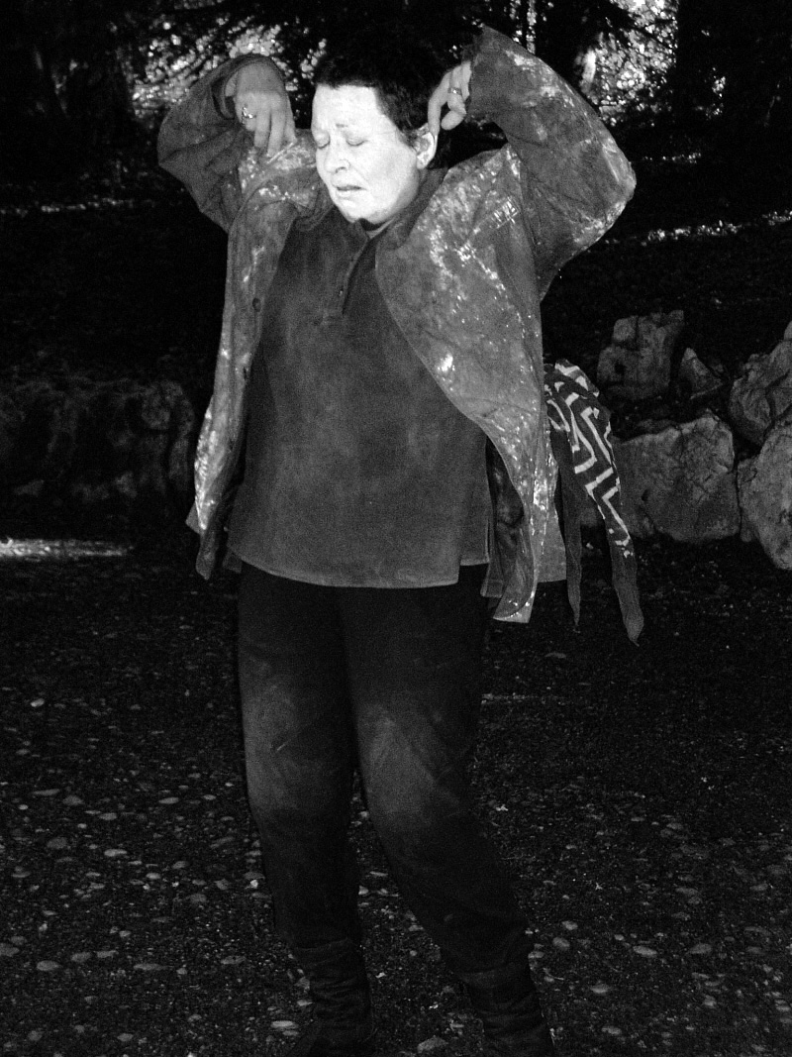

Analytical Body-Centered Work in Practice

Somatic exploration in individual sessions can take many forms. Perhaps a dream has very strong images that beckon. It is also possible to explore certain archetypal, polar-opposite energies particularly germane to the mover: depletion/vitality, creation/destruction. An embodied exploration of polarized energies can often yield a "third" element arising unexpectedly and surprisingly to inspire resolution.

In the sessions and courses I conduct there is no specific method employed. Rather, I listen very carefully to the emerging needs of the moment and then draw from a variety of approaches gathered over a period of almost 30 years.

Within the context of this essay, I can offer only limited examples. Although it is virtually impossible to communicate the actual experiences in words, hopefully the following will illustrate at least some dimension of the ideas here presented.

This is from the journal of a person with whom I worked over a concentrated period of time and is used here by permission from the participant:

I focused on a dream I had…about my father. As I dropped more deeply into his gestureless gesture [in the dream], I noticed how strongly my attention was pulled to my/his left arm (the one which was broken and torn off by the oncoming car when I was 4 years old. And sewed back on and held together by metal pins for the rest of his life.) As I dreamed into his body, as I sank deeper and deeper, away from my mental body and into micro-sensations, I was aware that my left arm was completely cold! The rest of my body was warm.

Re-emerging from this process, feeling my father in a visceral way, somehow opened the door of compassion [for him]. He was tormented by the death of my brother, his favorite son, and his love/disease of alcohol.

I remember Cedrus' words: "When we drop deeply into our experience, physical, psychic and emotional defenses begin to crumble….Let the image drop from the mind into the body. That which listens, listens from the inside. Let the body become the ear in listening. If you feel like you're falling apart, that's perfect. If we stay intact, we'll never open up enough to be able to listen well."

As mentioned above, I also work with the embodiment of analysands' images that come from other than dreams. In this instance, we worked with a painting the analysand made when starting the analysis.

This particular painting was of a female torso standing on a surging sea of fang-like waves. Streaming out of the pelvic area was a large arc of dark red paint. She said she had no idea what the painting was about, but that she just "had to paint it." She was very concerned about the dark red area in the pelvic region.
I asked if she wanted to explore the painting through her own body, especially since it was an image of the body that she had painted. Although she expressed fear about what would come up, her desire to learn more took precedence. I asked if she would like to lie down on the floor; I put a pillow under her head and covered her with a blanket, letting her know that she could stop at any time. As she explored the image in her pelvic area by deeply connecting with that part of her body, that is, by moving her awareness down, listening, waiting for any impulses or sensations, she began to cry. She cried for a very long time, without saying anything. After she returned from this internal voyage, she said she realized the painting was about the abortion she had had years ago.

As a result of letting herself be guided by the body's impulses and sensations, prompted by the image from the unconscious in the form of her spontaneous painting, she was able to connect with her pain and grief. She was able to mourn the loss of her child and begin to release the oppressive shame and guilt that had engulfed her as a result. She had never told anyone before, holding the experience down, deep in her body for many years. Her long-held fear of never having a successful relationship or a child dissolved in the course of the analysis into a loving marriage and three beautiful children.

Epilogue

It is my experience, as both patient and practitioner, that working through the body to access the unconscious is one of the most empowering venues for self-generative healing. Working through the body, we include aspects of life that have become dangerously marginalized. We begin to heal the wounding split that is created by the disenfranchisement of the very thing this approach embraces: the wisdom of the body, the somatic Sophia.

References

Chodorow, Joan. 1991. Dance therapy and depth psychology: The moving imagination.
London: Routledge.

Jung, C. G. 1998.Visions Seminar 2: Notes of the seminar given in 1930-1934. London:
Routledge; pp 1313-14.

Jung, C.G. 1954/1960. On the nature of the psyche. In CW 8.

Monte, Cedrus. 2005. Numen of the flesh. Quadrant XXXV,2: 11-31.

Rolf, Ida P. 1978/1990. Rolfing and physical reality. Rochester, Vermont: Healing Arts
Press.

Woodman, Marion. 1996. Dancing in the flames. Boston: Shambala Press.

Cedrus Monte, PhD., is a graduate of the C.G. Jung Institute in Zurich. Originally from the San Francisco Bay Area, she now lives and practices in Zurich, Switzerland. The organizing principle in all her endeavors has been the vitalizing force of the creative impulse.

